Dr. Akinbiyi
Dr Wiens
Queen Elizabeth II Hospital
________________________________________________________________
Shoulder and Upper Extremity Research Group of Edmonton (SURGE) Rehabilitation Guidelines

Total Shoulder Arthroplasty/
Hemi-Arthroplasty

- Total Shoulder Arthroplasty
- Hemi-Arthroplasty

Phase 1: Immobilization (0-4/6 weeks)
- Remain in shoulder immobilizer for up to 6 weeks as dictated by surgeon even when you are sleeping
- Placing a pillow behind your arm at night so it does not fall backwards or sleeping in a recliner may be more comfortable for the first few weeks.
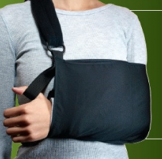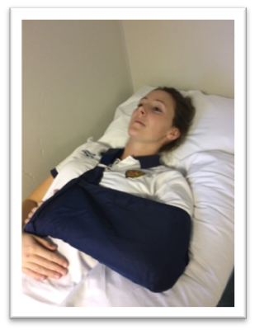

- You may come out of the sling 3-4 times a day for washing, physiotherapy exercises and simple ADL’s (brushing teeth, eating, writing) if pain-free.
- Caution:
  - No lifting, pushing, and/or pulling with the surgical arm
  - Do not actively (on its own power) turn your arm outwards (external rotation) or actively (on its own power) bring the arm out to the side (abduction)
  - Do not actively (on its own power) turn your arm inwards towards your stomach (internal rotation)

Pain and Swelling Control:
- It is common to have pain for the first 2-6 weeks after surgery
- Discomfort is normal, especially with exercise
- Cold Therapy is very beneficial and may be used to help control pain and assist in healing. Cold Therapy can be used for 20 minutes, every 1-2 hours as needed. If using ice packs, place a dry towel over your incision to keep it from getting wet.

When exercising:
- Exercises start immediately (Day 1 after the operation)
- Do each exercise 2-3 times a day
- Do 2 sets of 10 repetitions (reps) for each exercise
- Move within pain-free limits (discomfort is okay)
- Use your non-operated arm or a cane (broom handle, hockey stick, putter etc.) to move the operated arm – these exercises are called “active-assisted” range of motion (AAROM), as you always assist your arm to move.

Exercises after surgery

Hand/Wrist and Elbow Exercises
Complete these exercises with your arm in your sling or supported closely at your side resting on a pillow. Repeat these exercises 2-3 times/day, 10 repetitions each

- Hand
Gently close your hand as far as you can, then open it fully. You may squeeze a soft sponge ball.
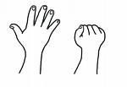
- Wrist
Bend your wrist a) forwards and backwards (knocking motion), b) side to side (hammering motion) and c) rotate palm up and palm down.

a) 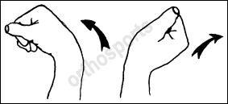 b) 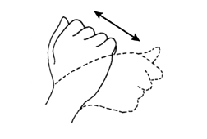 c)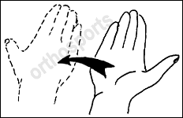

- Elbow
Remove your arm from your sling with help from the other arm. Straighten your elbow as much as you can, keeping your hand along your body. Now, bend your elbow again until your fingertips touch your shoulder. Repeat 2 sets of 10 repetitions or as pain allows.

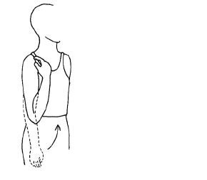

SHOULDER EXERCISES

1. Shoulder Retraction and Retraction/Depression:

- Sit in a chair with your arm in your sling or resting on a pillow, keeping your neck and shoulder muscles relaxed
- Gently move your shoulder blades (a) back and in towards your spine and hold for 10 seconds. (b)Then move your shoulder blades back, in and downwards
- May progress to sitting on a physio ball or standing
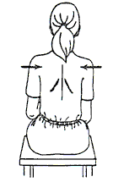

2. Standing Pendular Exercise
- stand supported beside a table or counter
- bend forwards at the waist about 30 degrees allowing your operated arm to hang in front of you
- gently use the momentum of your body to move your operated arm or your non operated/ “good” arm to move your operated arm in a circle (both directions) to the size of a dinner plate circumference only
*Do NOT use the muscles in the operated arm to move the arm
- repeat 2 sets of 10 in each direction
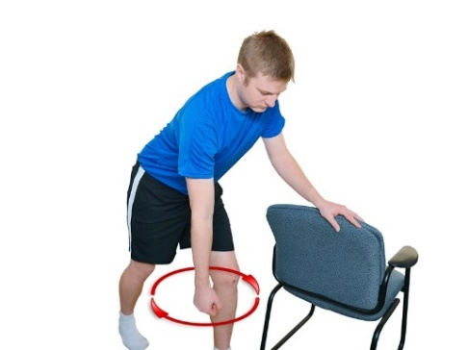

CIRCLES TO SIZE OF DINNER PLATE ONLY!

6. Shoulder Flexion and Scaption:
- Lying down with your operated shoulder and elbow supported on a pillow and your forearm resting on your abdomen
- Use your non operated/ “good” arm to hold your operated arm just above the wrist or at the elbow. You can also hold onto a cane/golf club etc. with both hands
- Gently lift your operated arm up towards your head as pain allows.

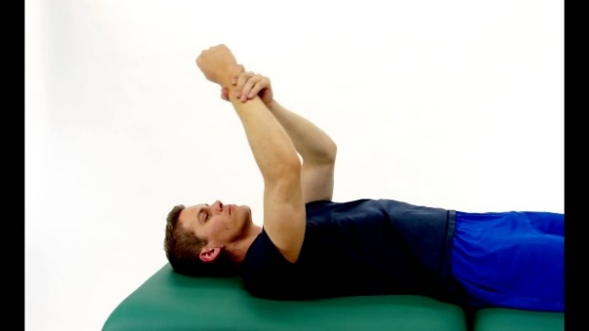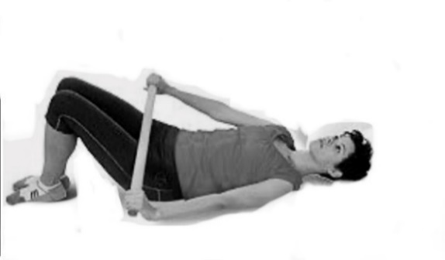

Flexion Scaption
(Flexion in the Scapular Plane -
Arms slightly away from body,
approximately 30 degrees)

- In standing, holding onto a cane or a golf club.
- Use your non operated/ “good arm” to move the cane and lift your operated arm straight forward (flexion).
- Now lift your arm slightly away from the body and forward (Scaption) to elevate your arm in the plane of the scapula.
- Repeat each direction, 2 sets of 10 repetitions as pain allows.

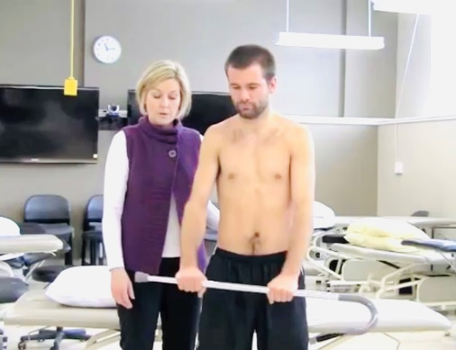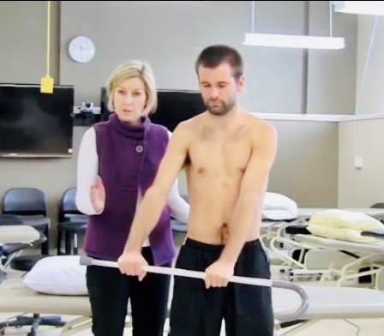
Flexion Scaption
(Flexion in the Scapular Plane -
Arm slightly away from body,
approximately 30 degrees)

7. Shoulder External Rotation:

- In standing or lying on your back with your arm on a pillow, holding onto a cane or a golf putter, keep your elbow tucked in closely by your side.
- Use your good arm to slowly rotate your operated forearm outwards from your chest to NEUTRAL ONLY

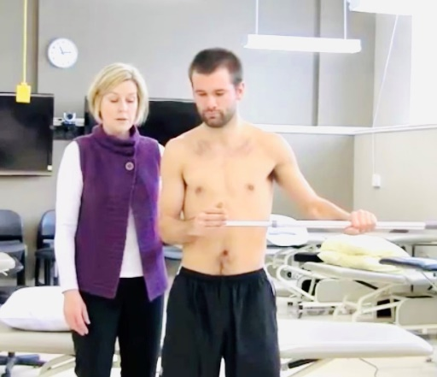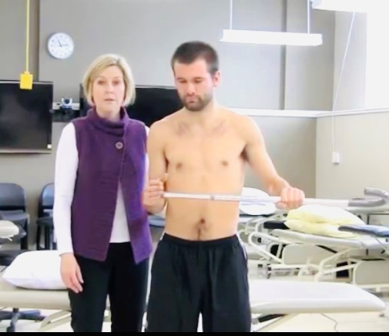

At ONE WEEK POST OP you may add the following exercises:

8) Shoulder Isometric Exercises:
- Do these exercises either with your operated arm in the sling or well supported on a pillow; place a towel between your chest wall and your elbow
- Wrap the hand of your non operated arm around the outside of the upper arm (near your elbow) of your operated shoulder for stabilization. Very gently and as pain allows, press your operated arm into your non operated hand and hold for 5 count in the following directions:
  - Press Forward
  - Press Backward

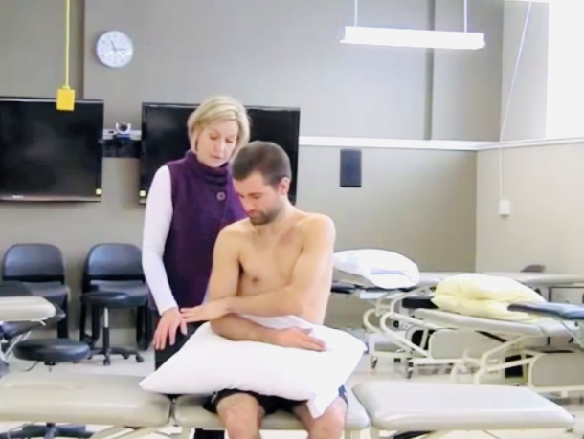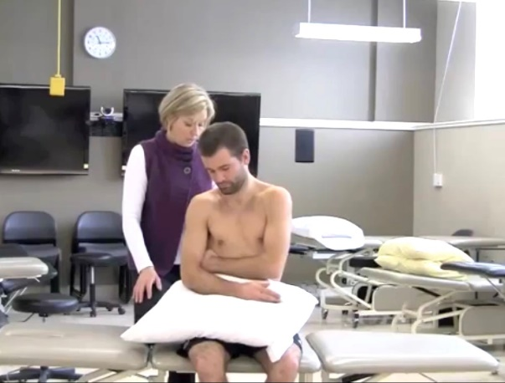
Forward Backward

- Now move your non operated hand down to your wrist. Very gently and as pain allows, press your operated arm into your non operated hand and hold for 5 counts in the following directions:
  - Press Outwards (NOTE: Pressing inwards (internal rotation) is not allowed)

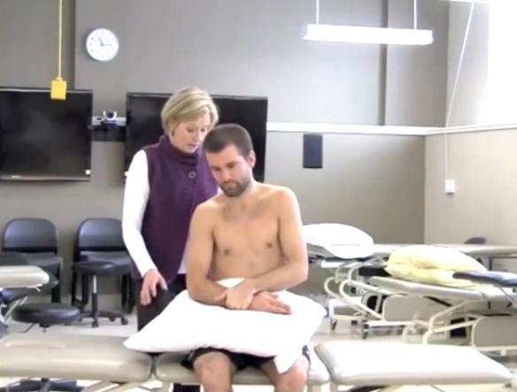
Outwards

* At 7 weeks, your Physiotherapist or Surgeon will progress you to the next phase of exercises

