Dr. Akinbiyi
Queen Elizabeth II Hospital
_______________________________________________________________________________
EXERCISES AFTER BACK SURGERY

- Perform only those exercises indicated and instructed by your physiotherapist
- Perform all exercises within your pain limits. If the exercises increase pain, stop the exercise, and try again the next day. If you are unable to do the exercises due to pain, consult your healthcare provider (e.g. surgeon or physiotherapist)
- If you experience new numbness, tingling, or increased weakness, consult your healthcare provider immediately

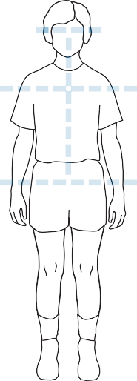
1. A Review of Good Posture: How to Find ‘Neutral Spine
Good posture ensures your spine is in the correct position. We call this position ‘neutral spine’. Before starting an exercise, always find neutral spine as follows:

Neutral spine standing or sitting
  - Stand with feet shoulder width apart, or sit on both sitting bones evenly
  - Bring your spine to neutral by tightening stomach muscles to tuck your bottom in
  - Imagine a string attached to the top of your head is being pulled up on
  - Bring shoulder blades together and down to your back
  - Tuck your chin slightly so that your ears are in line with your shoulders

Neutral spine lying on your back
  - Lie on your back with knees bent and feet flat on the bed
  - Make sure there is a small space between your low back and the bed. Your lower back should be halfway between arched and pressed flat to the bed
  - Imagine a string attached to the top of your head is being pulled up on

© Vancouver Coastal H

2. Deep Abdominals
Much of the stability in your lower back comes from deep muscles in your abdomen and pelvis. It is hard to feel them working and you may need some practice before you can learn to work them.
  - Lie on your back with knees bent and feet flat on the bed, and find neutral spine
  - Place your fingertips on each side of your lower abdomen just above your pelvis
  - Keep your upper body relaxed and breathe gently
  - Gently tighten stomach muscles as if trying to pull bellybutton in towards your spine. You should feel a gentle tightening under your fingertips, but no movement at the spine
  - As you become more comfortable, try to hold the gentle contraction for longer periods of time. Also try it in different positions (sitting, standing, walking)
Repeat times
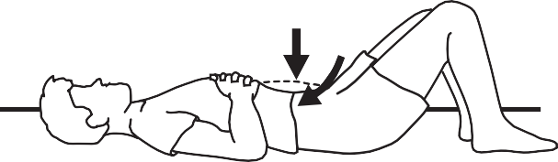
© Vancouver Coastal Health

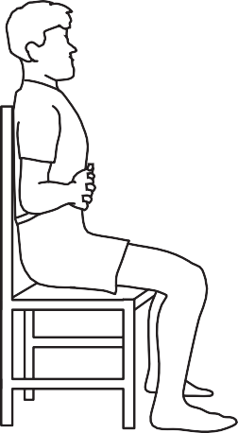
3. Diaphragmatic Breathing
Your diaphragm is an important muscle of breathing that can also help with the stability of your lower back. Breathing well can help with oxygenation, relaxation, and pain control.
  - Relax your neck and shoulders
  - Find neutral spine (this may be in lying, sitting, or standing)
  - Place your hand on your stomach over the lower ribs
  - Take a deep breath in and out in a relaxed manner
  - You should feel your hand rise as you breathe in and fall as you breathe out

4. Neural Glides in Sitting
Neural glides can stop your nerves from getting stuck or bound down by scar tissue as you heal.
  - Sit tall with a neutral spine
  - Keep the shoulders relaxed and directly over the pelvis. Breathe gently
  - Slowly straighten one knee. Do not move it past any tension. Remember to keep the back and pelvis stable, in a neutral position
  - Move your ankle slowly so you point your toes up, then down
Repeat times on both sides

© Vancouver Coastal Health

© Vancouver Coastal Health

5. Neural Glides in Lying

- Lie on your back and lift the involved leg to 90 degrees, keeping the knee bent. This will be the starting position.
- Keeping the foot relaxed, extend the knee without moving the thigh.
- When the knee is extended at its most, actively pull the toes toward your shin. When you reach the point where you feel a pulling sensation along your leg, let go and return to the starting position and repeat.

Repeat ____________ times on both sides
(PhysioTec)

6. Knee Bends
Strong legs keep you moving safely and protect your back. Knee bends can help with your balance and walking pattern.
  - Stand with a neutral spine with hands supported on counter top or table
  - Place your feet shoulder width apart
  - Keep your knee caps aligned with the second toe
  - Slowly bend your knees (30-45 degrees maximum)
  - Slowly straighten legs, use both legs evenly Repeat times
© Vancouver Coastal Health

7. Walking Program
Walking is one of the best exercises to help you recover from the surgery. When walking, always make sure you adopt a good posture with a neutral spine.
  - Start with frequent, short walks on level ground
  - Each day increase the amount of time you spend walking
  - As your walks get longer, cut back the number of walks per day. This will allow you to increase your walking time and prevent getting too tired or sore
  - Make sure you wear comfortable clothing and footwear such as good running shoes
  - If nervous or unsure when walking outside, walk with someone
  - If walking with a walker, cane or poles, try to stand as erect as you can. Keep the walker close to you

Progression of Exercises
- Before returning to sports and other physical activities, obtain permission from your surgeon
- When your surgeon allows you to return to your regular activities, we recommend that you see a physiotherapist to progress this exercise program
- Book an appointment at a physiotherapy clinic after you follow-up with your surgeon to help you rebuild your strength, flexibility and improve the stability in your lower back

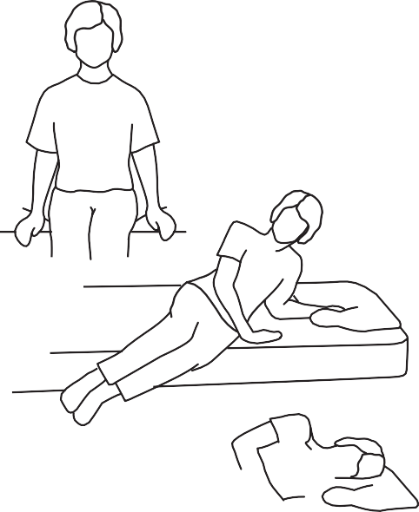
Reminder: Getting In and Out of Bed
© Vancouver Coastal Health

When getting into bed:
Sit on the edge of the bed. Lie down on your side. Stay on your side or log roll onto your back.

When getting out of bed:
Bend your knees up, roll onto your side. Drop your feet off the side of the bed and push up with your hand/forearm. Avoid twisting your back. Sit briefly on the edge of the bed before standing up straight.

Used with permission from Vancouver Coastal Health

