Dr. Akinbiyi
Dr. Wiens
Queen Elizabeth II Hospital
________________________________________________________________
Shoulder and Upper Extremity Research Group of Edmonton (SURGE) Rehabilitation Guidelines

- Standard Rotator Cuff Repair
  - Follow exercises #1-8, as described below

- Non-Standard
  - Large Repair, requiring longer period of immobilization before starting shoulder movement exercises. MUST KEEP SLING ON AT ALL TIMES except for washing.
  - Please do exercises #1-4 ONLY WITH SLING ON until your surgeon advises that you may progress to the other exercises (usually 4-6 weeks)

In addition, (you will be told after your surgery) if had a:
- Biceps Tenodesis
  - DO NOT bend your elbow on its own, use your non operated arm to bend your elbow. Use your non operated arm to assist your operated arm for EXERCISE #3

Phase 1: Immobilization (0-4/6 weeks)
- Remain in shoulder immobilizer for up to 4-6 weeks as dictated by surgeon
- You may come out of the sling 3-4 times a day for washing, physiotherapy exercises and simple ADL’s (brushing teeth, eating, writing) if pain-free.
- Placing a pillow behind your arm at night so it does not fall backwards or sleeping in a recliner may be more comfortable for the first few weeks.
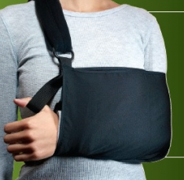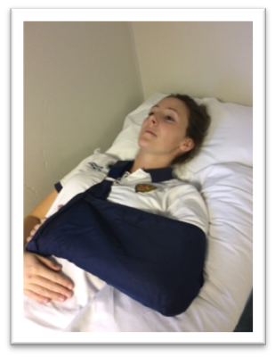

- No lifting, pushing, and/or pulling with the surgical arm.
- No ACTIVE movement of your operated shoulder x 6 weeks; ACTIVE ASSISTED range of motion only (your non-operated arm moves your operated arm and try to relax your neck, back and operated shoulder/arm muscles. This is important to allow the repaired muscles time to heal.
- No ABDUCTION (moving arm straight out to side) or arm behind back movement x 6 weeks.

Pain and Swelling Control:
- It is common to have quite a lot of pain for the first 2-6 weeks after surgery
- Discomfort is normal, especially with exercise
- Cold Therapy is very beneficial and may be used to help control pain and assist in healing. Cold Therapy can be used for 20 minutes, every 1-2 hours as needed. If using ice packs, place a dry towel over your incision to keep it from getting wet.

When exercising:
- Exercises start immediately (Day 1 after the operation)
- Do each exercise 2-3 times a day
- Do 2 sets of 10 repetitions (reps) for each exercise
- Move within pain-free limits (discomfort is okay)
- Always use your non operated arm or a cane (broom handle, hockey stick, putter etc.) to move the operated arm – these exercises are called “active-assisted” range of motion (AAROM), as you always fully assist your arm to move.

Exercises after surgery

Hand/Wrist and Elbow Exercises
Complete these exercises with your arm in your sling or supported closely at your side resting on a pillow. Repeat these exercises 2-3 times/day, 10 repetitions each.

- Hand

Gently close your hand as far as you can, then open it fully. You may squeeze a soft sponge ball.
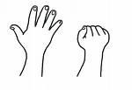

2. Wrist

Bend your wrist a) forwards and backwards, b) side to side and c) rotate palm up and palm down.

a) 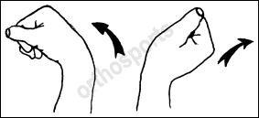 b) 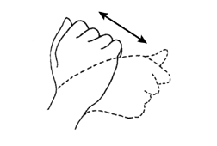 c)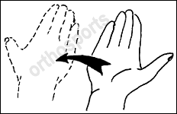

3. Elbow *** For BICEPS TENODESIS, your non operated arm MUST help your operated arm bend your elbow x 6 WEEKS

Remove your arm from your sling with help from the other arm. Straighten your elbow as much as you can, keeping your hand along your body. Now, bend your elbow again until your fingertips touch your shoulder. Repeat 2 sets of 10 repetitions or as pain allows.
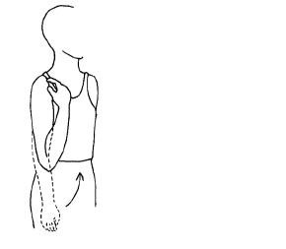
SHOULDER EXERCISES

Repeat these exercises 2-3 times/day, 2 sets of 10 repetitions each or as pain allows.

4. Shoulder Retraction and Retraction/Depression:
- Sit in a chair with your arm in your sling or resting on a pillow, keeping your neck and shoulder muscles relaxed
- Gently move your shoulder blades (a) back and in towards your spine and hold for 10 seconds. (b)Then move your shoulder blades back, in and downward. May progress to sitting on a physio ball or stand.
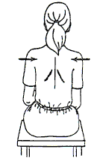

5. Standing Pendular Exercise

- Stand beside a table or counter supported by your good arm, with feet in a step stance position
- Bend forwards at the waist allowing your operated arm to hang in front of you
- Gently use the momentum of your body or your non operated arm to move your operated arm in a circle to dinner plate circumference only
- *DO NOT use the muscles in the operated arm to move the arm.
- If your PT instructs you to, place your shoulder blade in a forward position or back position (scapular retraction/protraction) and repeat the pendular exercise in the new positions
- Repeat 2 sets of 10 in each direction (clockwise & counterclockwise).

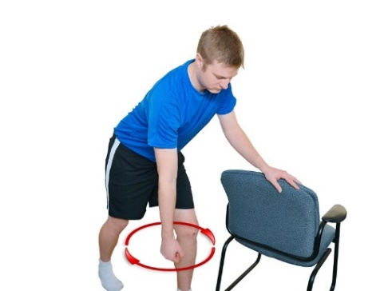

CIRCLES TO SIZE OF DINNER PLATE ONLY!

6. Shoulder Flexion and Scaption:
- Lay down with your operated shoulder and elbow supported on a pillow and your forearm resting on your abdomen
- Use your non operated arm to hold your operated arm just above the wrist or at the elbow. You can also hold onto a cane/golf club etc. with both hands
- Gently lift your operated arm up towards your head as pain allows.

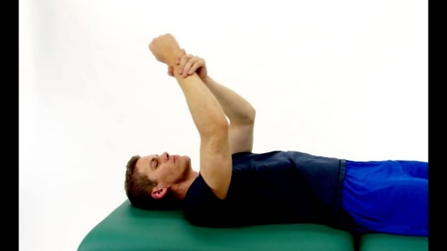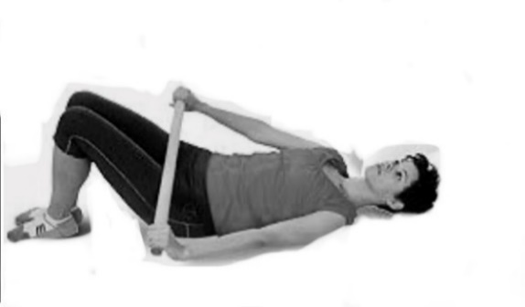

Flexion Scaption
(Flexion in the Scapular Plane -
Arms slightly away from body,
approximately 30 degrees)

7. Shoulder External Rotation:

- Lay down with your operated shoulder and elbow supported on a pillow and your forearm resting on your abdomen
- Keep your operated elbow against your side and bend your elbow to 90 degrees
- Use a cane and your good arm to rotate your operated forearm outwards from your body as pain allows
- Hold onto the cane to return your arm to rest on your abdomen.

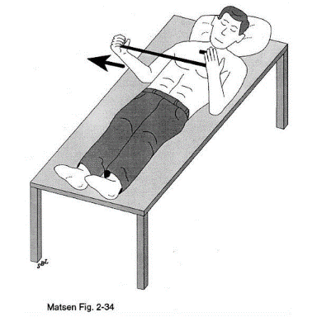
8. Shoulder Extension:

- Rest your operated arm on a table with your elbow bent at 90º.
- Gently use the hand of your good arm to push the operated arm backwards behind your body, as far as the operated shoulder is pain-free. Use your good arm to move your arm back forward again.

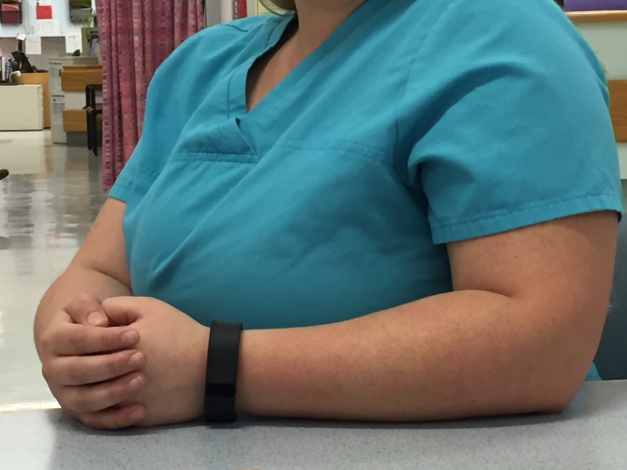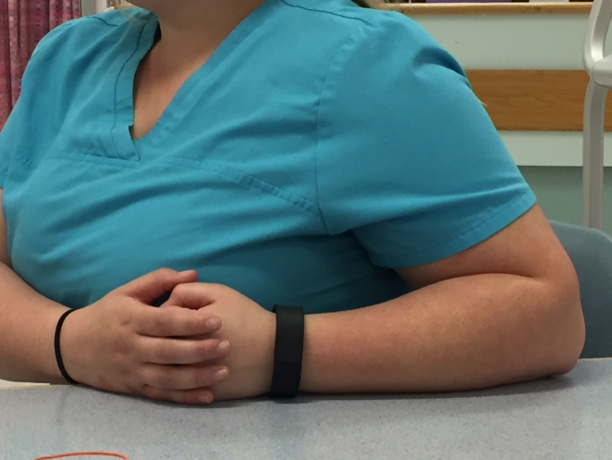

Additional information:
Videos for some of the shoulder exercises can be viewed at
https://youtu.be/SpcCCARPQPE or
http://rehabilitation.ualberta.ca/research/research-groups/shoulder-and-elbow-research-group-of-edmonton/shoulder-rehabilitation-guidelines (Under: Videos: Phase I - Standard RC Guidelines)

