Post-Surgery
Rehabilitation Program

Multiligament Reconstruction/
PCL Reconstruction

Dr. Akinbiyi
Dr. Wiens

October 2018

This protocol is designed to assist you with your rehabilitation after surgery and should be followed under the direction of a physiotherapist.

PHASE 1: Early Post-operative Phase
This is the initial recovery phase and it normally lasts up to 6-weeks post-operatively. In the first 1-2 weeks you should rest and elevate your leg for a significant amount of the time.

GOALS

Reduce inflammation and swelling
Range of Motion: 0°-90° by 6-weeks post-operative Quadriceps muscle activation
KNEE BRACE
During the first 1-2 weeks following surgery, your knee must be locked in full extension at all times (including sleeping) in order to protect your grafts. Your surgeon will decide how long your knee has to be braced in full extension based on the extent of surgery, your muscle strength and knee stability.
Your surgeon will allow you to unlock the brace around 2-weeks after surgery to allow knee bending (flexion) to 90°. Knee flexion, while wearing your brace, will gradually be increased at the discretion of your surgeon.
Your brace will be discontinued between 8-12 weeks post-operatively. Your surgeon will decide how long you will need to wear your brace after surgery, based on the integrity of your grafts, quadriceps strength, walking quality and the overall stability of your knee joint.

WEIGHT BEARING
You can “feather” weight bear with crutches for the first 1-4 weeks post-operatively. This means you can rest your foot on the floor for balance but cannot put any weight through your leg. You will progress to partial weight bearing around 4-6 weeks after surgery while continuing to wear your brace. Once your surgeon allows you to start partial weight bearing, use your crutches for support while putting about 50% of your weight through your operative leg. Continue wearing your brace and use your crutches to walk using a normal “heel- toe” pattern. Do not attempt to fully weight bear until 8-12 weeks post-operatively. Your progression to full weight bearing without your brace or crutches will take between 8-14 weeks after surgery, and will depend on your swelling, pain, and strength. Your surgeon must clear you before you start full weight bearing.

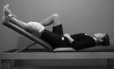
COLD THERAPY & ELEVATION
A Cold Therapy Unit or an ice pack should be applied immediately after surgery and used for at least 20 minutes every other hour while you are awake. Your operative leg should be braced and elevated with the knee straight and supported when applying cold therapy and/or when resting.

EXERCISES

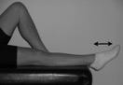
Ankle Pumps:
- Your foot and ankle should be actively “pumped” up and down 10-20 times every hour.

Range of Motion:
IMPORTANT: Do not start these exercises until 2-weeks after your surgery. In multiligament knee reconstructions that include the PCL, the hamstrings have a tendency to pull the tibia posteriorly when the knee is flexed, which can potentailly stretch your graft. We recommend prone exercises to use gravity to counter this pull.
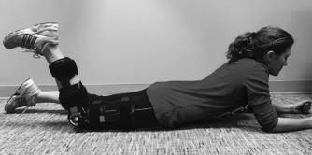
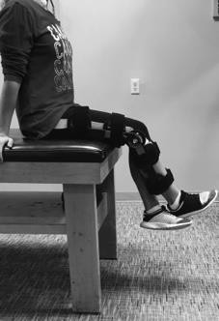
- Active Prone knee bend: Lying on your stomach, with your brace unlocked from 0°- 90° and both knees straight, slowly bend your knee until a stretch is felt (in the knee or in front of the thigh). Hold for a count of 10 seconds and return to the initial position. Perform exercise 10 times. You should not bend your knee beyond 90°. Make sure that your brace is unlocked only from 0°- 90°.
- Sitting knee bend: Sitting on a chair or table, with your brace unlocked from 0°- 90°, slowly bend your knee until a stretch is felt (in the knee or in front of the thigh). You can help to support your operative leg by tucking your opposite leg underneath it. Hold for a count of 10 seconds and return to the starting position. Perform the exercise 10 times. You should not bend your knee beyond 90°. Make sure that your brace is unlocked only from 0°- 90°. Try not to activate or contract your hamstring muscles during this exercise as it can place strain on your grafts.

Strengthening:
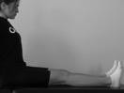
- Quadriceps Contraction:While wearing your brace and sitting with your knee straight and leg supported, tighten your thigh muscle by pushing your leg downwards. Focus on tightening the muscle and avoid lifting your leg from the hip. Perform exercise 5-10 times holding each contraction for 5 secs. Progress to 30 times holding each contraction for 10 secs, resting for 5 secs in between reps. The use of EMS (Electric Muscle Stimulation) is recommended for this exercise.
IMPORTANT: Do not push your knee backwards (beyond straight) to hyperextend your knee.
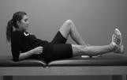
- Straight Leg Raises: While wearing your brace, in the position shown, tighten your thigh muscle and lift your leg up 2 inches. Perform exercise 5- 10 times holding each contraction for 5 secs. Progress to 30 reps holding each contraction for 5-10 secs. The use of EMS is recommended for this exercise.

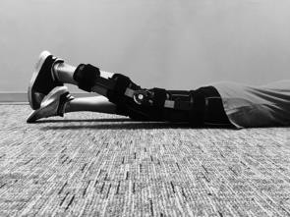
- Prone Hip Extension: While wearing your brace, lie on your stomach in the position shown. Lift your leg off the bench by tightening your buttock muscles and keeping your leg straight. Perform exercise 5-10 times holding each contraction for 5 secs. Progress to 15 reps holding each contraction for 10-15 secs, resting for 5 secs between each repetition.

- 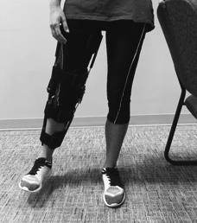Hip Abduction: While wearing your brace, stand on your non-operative leg and lean against a counter, desk, or table. Lift your operative leg out to the side, away from you, keeping it straight. Perform exercise 5-10 times holding each contraction for 5

Page 2 of 16

secs. As your knee allows, gradually increase the angle at which you stretch your leg out to the side. Progress to 30 times holding each contraction for 10-15 secs, resting for 5 secs between each repetition.

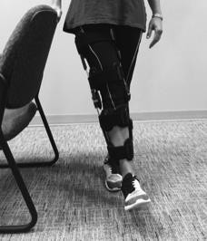
- Hip Adduction: While wearing your brace, stand on your non-operative leg and lean against a counter, desk, or table. Lift your operative leg sideways across your body in front of you, keeping it straight. Perform exercise 5-10 times holding each contraction for 5 secs. As your knee allows, gradually increase the angle at which you stretch your leg across your body. Progress to 30 reps holding each contraction for 10-15 secs, resting for 5 secs between each repetition.
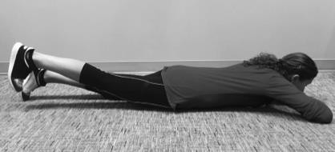
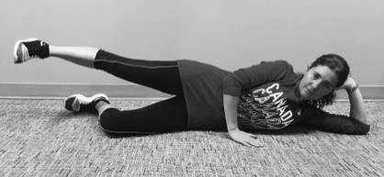
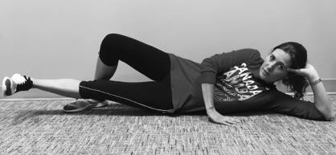
IMPORTANT: To avoid full weight bearing on your operative leg you can do the Hip Extension, Hip Abduction and Hip Adduction exercises with your non-operative leg by sitting on a physio table or in a lying position.

Stretching:
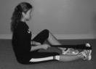
- Calf: Sitting with your knee straight, wrap a towel around your foot and gently pull your toes and foot towards you. Hold each stretch for at least 30 secs and repeat 4 times.

** Perform all exercises 2-3 times per day to improve your strength and range of motion.
You should perform all of the exercises on both legs, BUT NOT WEIGHT BEARING on your operated leg! **

ALSO CONSIDER:
- Hip and ankle strengthening as tolerated

REQUIREMENTS FOR PROGRESSION TO PHASE 2

Full knee extension
  - Ability to activate quadriceps (specifically VMO)
  - Knee flexion to 90°
  - Pain and swelling levels managed to enable exercise progression

PHASE 2: Motion, Strength and Core Stability
This is the initial muscle-strengthening phase and it normally begins at around 6- weeks and lasts until 12- weeks post-operatively. This phase emphasizes increased range of motion (ROM) in flexion and progressive strengthening of the quadriceps muscles along with core strengthening.

GOALS

Manage pain and swelling
Range of Motion: 0° to ≥ 125° by week 12 post-operative Able to perform a straight leg raise
Progress to full weight bearing with normalized gait Use stationary bike in daily exercise program Increase bilateral leg strength and core control
WEIGHT BEARING
Wearing your brace you can begin to work up to full weight bearing at 6-8 weeks post-operatively. You should be able to achieve full weight bearing without using crutches or a cane between 8-12 weeks after surgery. Before you stop using your crutches you need to be able to take full weight on the operative leg and walk with only a slight limp. If you still need support to walk normally, you may use one crutch or a cane, depending on the recommendation of your surgeon.

KNEE BRACING
Your brace may be discontinued between 8-12 weeks post-operatively. Your surgeon will decide the extent of time at which you wear your brace, based on the integrity of your grafts, quadriceps strength and the overall stability of your knee joint.

COLD THERAPY & ELEVATION
Manage your swelling by continuing to use cold therapy and elevation, especially after exercise or physiotherapy sessions.

EXERCISES

Range of Motion:
IMPORTANT: if you had a Meniscal Repair you should not force flexion (bending) in the first 12 weeks.
If your knee is very stiff, it is not uncommon for the surgeon to do a manipulation under anesthetic between 6-12 weeks post-operatively to help improve your knee range of motion.
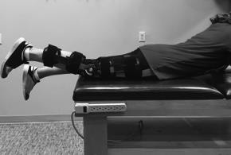
- Prone knee hang: Lying on your stomach, let your legs hang off the bed. Allow your knee to straighten as much as possible. Hold for a count of 30 seconds and return to the initial position. Perform exercise 20 times.

- 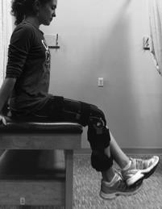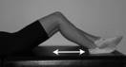Passive sitting knee bend: sitting on a chair or table, with your brace on (or without, if you are past 8 weeks), bend your knee until a stretch is felt. You can help to push back with your non-operated leg. Hold for a count of 10 seconds and return to the initial position. Perform exercise 10 times. Try not to activate or contract your hamstring muscles during this exercise as it can place strain on your grafts.
- Knee flexion in supine: Lying on your back, bend your knee by sliding your heel towards your buttocks. Use your other leg to help you at the end of your range of motion if needed. Hold for a count of 10 seconds and return to the initial position. Perform exercise 10 times.
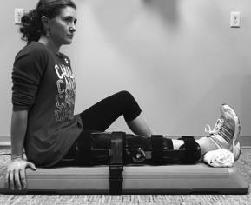
- Knee Extension: If full knee extension has not been achieved, find a flat board, coffee table or a broom. Place your operated leg on the board or broom (the broom stick should be just beside your sit bone). Place a rolled up towel underneath your ankle. Strap your knee against the board or broom stick (you may use a belt or any firm straps) and pull it as tight as you can to force your knee into extension. Maintain it for around 15 minutes and, if tolerable, tighten the strap every few minutes. Perform the exercise 3 times a day.

Strengthening:
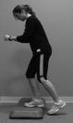
- Step-ups: Do graduated heights, starting at 4” and increasing to 8”.
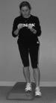
Stand in front of a stair or stepping stool and place one foot on the step in front of you. Rise up onto the step by shifting all of your weight onto this leg and tighten your quadriceps muscles. Put all of your weight through this leg and do not step up onto the step with your other leg. Start with one set of 10 reps, holding at the top of the step-up for 5 secs. Increase the number of reps as your strength increases, up to 20 reps with 15 secs holds on each leg. EMS is recommended for this exercise with the ‘contraction’ time at least double the ‘rest’ time.
- Step-downs: Do graduated heights, starting at 4” and increasing to 8”.
Start with one leg standing on the step and slowly bend your knee to lower your other leg to lightly touch floor. Keep all of your weight through the leg that is on the step. Start with one set of 10 reps, holding at the bottom of the step-down for 5 secs. Increase the number of reps as your strength increases, up to 20 reps with 15 secs holds on each leg. EMS is recommended for this exercise with the ‘contraction’ time at least double the ‘rest’ time.

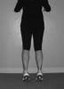
Calf Raises:
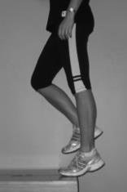
Both legs: Start with feet shoulder width apart and toes pointed straight ahead, and raise up onto your toes. Start with one set of 10 reps, holding each raise for 5 secs. Increase the number of reps up to 30 with 5 sec holds. Start by using support at a wall or table and progress to no support as able. Single leg: Start on one leg with toes pointed straight ahead, and raise up onto your toes (use crutches if you are not ready to full weight bear). Start with one set of 10 reps, holding each raise for 5 secs. Increase the number of reps up to 20 with 5 sec holds on each leg. Start by using support at a wall or table and progress to no support as able.

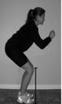
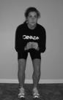
- Quadriceps: Slowly squat with equal weight on each leg. Bend your knees from 0° to a maximum of 90° of flexion, making sure your knees do not move beyond your toes. Start with one set of 10 reps, holding each squat for 5 secs and increase the number of reps as your strength increases, up to 30 reps x 15 secs hold. EMS is recommended for this exercise with the ‘contraction’ time at least double the ‘rest’ time.

- 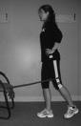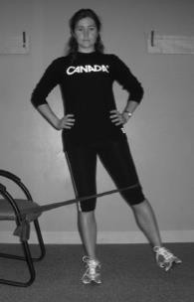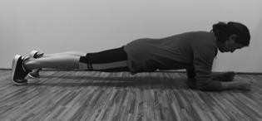Hip Abduction: In the position shown, with a resistance band around your outside thigh just above your knee, lift your leg to place slight tension on the band. Move this leg sideways slowly against the resistance of the band using the muscles in your buttock and your hip. Start with 1 set of 10 reps and increase to 3 sets of 15 reps

- Hip Extension: Stand with legs shoulder-width apart with a resistance band around one of your thighs just above your knee as shown. Extend your leg to place slight tension on the resistance band. Slowly move the leg backwards against the resistance of the band using the muscles in your buttock and the back of your thigh. Start with 1 set of 10 reps and increase to 3 sets of 15 reps
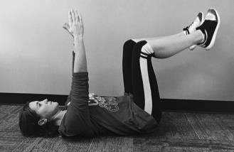
- Planks: Place the forearms on the ground with the elbows aligned below the shoulders, and arms parallel to the body at about shoulder-width distance. Engage your core and glute muscles and lift the hips up off the ground. Start with one set of 10, holding each lift for 15 secs. Increase the holding time as your strength increases.
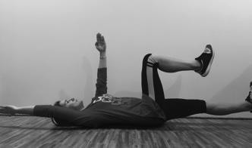
- Dead Bugs: Lie flat on your back with your hands extended above you toward the ceiling. Bend your knees in a 90-degree angle and raise your thighs until they are perpendicular to the floor. Now deeply exhale and engage your abs to bring your ribcage down and flatten you back onto the floor. Slowly lower the right arm and the left leg down to the floor simultaneously. Lower them down until just before the lower back starts to arch off the ground. On your way down exhale. Then slowly return to the starting position while inhaling. Alternate sides. Start with one set of 10, holding each lift for 5 secs. Increase the number of reps as your strength increases.
- Thigh Adduction: In lying with your knees bent as shown, squeeze a soft ball or a pillow between your knees. Perform exercise 5 - 10 times holding each contraction for 5-10 secs. Progress to 30 times holding each contraction for 10- 15 secs, resting for 5 secs between reps.
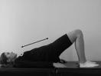
- Gluteals: In lying with your knees bent and your arms by your sides, squeeze your buttocks and lift up to create a bridge. Keep equal weight on each leg and straight alignment from your shoulders to your knees. Be careful not to push down on your neck or shoulders – use your buttocks to do the work. Start with one set of 10 reps, holding each lift for 5 secs. Increase the number of reps as your strength increases. Once you can complete 20 reps holding for 10 secs each, change to single leg bridges.

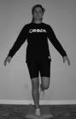
Proprioception:
- Single leg stance (eyes open → eyes closed)

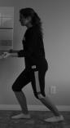
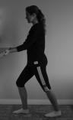
Stretching:
- Calf: Standing at a wall in the positions shown. Lean forward until you feel a stretch in your calf. Hold each stretch for at least 30 seconds and repeat 4 times. Do exercise with back leg straight and again with back leg slightly bent.

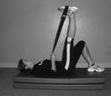
- Hamstring stretch: In lying, place a towel or belt around your foot and bring your leg up until a stretch is felt at the back of the thigh. Hold each stretch for at least 30 seconds and repeat 4 times.

** Perform all exercises once per day, 4-5 days per week to improve your strength and range of motion. You should perform all of the exercises on both legs**

ALSO CONSIDER:
- Stationary bike 20-30 minutes, 4-5 times per week.
- Normalizing gait with/without crutches
- Gentle walking in the pool if cleared by your surgeon. No swimming/whip kick allowed.
- Abdominal and core strengthening (i.e. curl-ups, obliques, isometric holds, transverse abdominis, planks and Pilates)

REQUIREMENTS FOR PROGRESSION TO PHASE 3

Range of motion of 0° to ≥ 125°
  - Single leg calf raise
  - Pain and swelling levels managed to enable exercise progression
  - Good control and alignment during hip and core strengthening exercises
  - Normal gait

PHASE 3: Muscle Strength and Control
This phase normally lasts from 3-6 months post-operatively, but may last up to 9 months. This phase focuses on achieving full range of motion (ROM) and improving muscle bulk, muscle control, balance and proprioception.

GOALS

Full range of motion (ROM)
Increase quadriceps, hamstrings, gluteal and core strength using advanced dynamic exercises Improve proprioception and balance
Aerobic activity for 20-30 minutes per day, 3-4 times per week

WEIGHT BEARING
You should be full weight bearing with a normal gait pattern without using a brace or walking aids.

COLD THERAPY & ELEVATION
Manage your swelling by continuing to use cold therapy and elevation, especially after exercise or physiotherapy sessions.

EXERCISES

Range of Motion: Continue active assisted and passive range of motion exercises to ensure full range of motion.
IMPORTANT: It is common in a multi-ligament surgery to lose 15° of flexion in the operative knee compared to the non-operative knee. This is due to the extent of the initial injury as well as the amount of scar tissue that occurs with this large reconstruction surgery.

Strengthening:
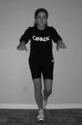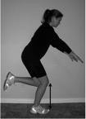IMPORTANT: Do not progress your number of repetitions or sets if your form is deteriorating!
- Single leg squats: Standing on one leg, slowly squat bending your knee from 0° to a maximum of 90°, making sure your knee does not move beyond your toes. Start with one set of 10 reps, holding each squat for 5 secs and increase the number of reps as your strength increases, up to 30 reps x 15 sec holds on each leg.
- 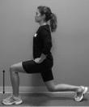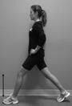Lunges: Standing with feet as pictured, squat down to lunge as shown. Control the descent ensuring your knee that is forward does not move beyond your toes. Start with 1 set of 10, holding each lunge for 5 secs. Increase the number of reps as your strength increases, up to 3 sets of 10 on each leg.

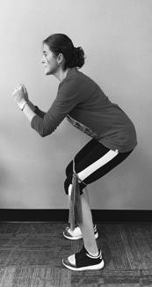
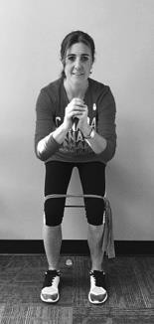
- Squats with rubber band: Stand with legs shoulder width apart with a resistance band around your thighs just above your knees. Slowly squat with equal weight on each leg. Bend your knees from 0° to a maximum of 90° of flexion, making sure your knees do not move beyond your toes. The rubber band will push your knees into internal rotation (inwards), so make sure the patella is aligned with the second toe the whole time.
Start with one set of 10 reps, holding each squat for 5 secs and increase the
number of reps as your strength increases, up to 30 reps x 10 secs hold. EMS is recommended for this exercise with the ‘contraction’ time at least double the ‘rest’ time.
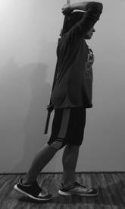
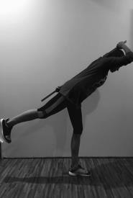
- Single leg dead lift with pole: Stand on your non-operated leg first and hold the pole behind your back to keep it in a neutral position. Keep the supporting knee still. Flex forward from the hips, allowing the opposite hip to extend while keeping the spine neutral and the hips facing forward. The foot that goes up should be pointed down to help prevent hip rotation. Hinge forward through the hips only as far as you are able to maintain a neutral spine, keeping the shoulders and hips parallel to the floor.
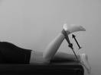
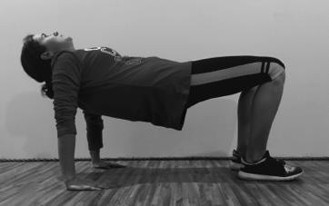
- Reverse bridge: Place your palms, with fingers spread wide, on the floor slightly behind and outside your hips in a sitting position. Press into your palms, and lift your hips and torso toward the ceiling, trying to keep a straight line from head to knees, which will be bent at 90 degrees. Hold for 10 seconds and slowly lower the hips back down. Increase the number of reps as your strength increases, building up to 15 reps with 10 sec holds for each leg.
- Hamstrings: Lying on your stomach, place a resistance band around your ankle and also have it attached to an anchor point as shown. Slowly bend your knee against the resistance of the band pulling your foot towards your buttocks. Start with 1 set of 10 reps and increase to 3 sets of 15 reps.
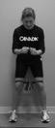
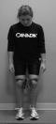
- Hip abduction: In standing with legs hip width apart and feet pointing forwards, tie a resistance band around your thighs as shown. Take a sideway step against the resistance of the band and then step back to the starting position with your other leg. Start with 10 steps to the left and 10 steps to the right, and increase to 3 sets of 15 steps to the left and 15 steps to the right.

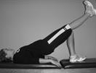
- Gluteals: Single leg: In lying with your knees bent and your arms by your sides, squeeze your buttocks and lift up to create a bridge. Straighten one knee and hold that leg in the air. Keep straight alignment from your shoulders to your knees. Be careful not to push down on your neck or shoulders – use your buttocks to do the work. Start with one set of 10, holding each lift for 5 secs. Increase the number of reps as your strength increases, building up to 15 reps with 10 sec holds for each leg.

- 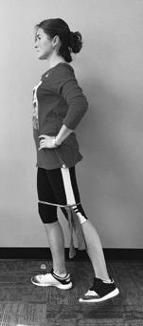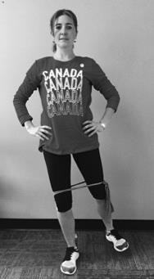Combination: Hip extension + external rotation + abduction: In standing with legs hip width apart and feet straight forwards, tie a resistance band around your thighs as shown. Move your leg outwards and backwards in a 45- degree angle with your toes slightly pointing out. Keep your pelvis square and still, so you don’t compensate with your back muscles. Engage your “back pocket muscles” as you perform the movement. Start with one set of 10, holding each movement for 5 secs. Increase the number of reps as your strength increases.
- Core: Increase core strength.
Some exercise ideas include bridging with legs on physio ball, bridging with back on physio ball, sit ups on physio ball, side sit ups on physio ball, “dead bug” on a BOSU and Pilates core exercises

Proprioception:
- Single leg stance on an unstable surface (thick carpet → foam block → camping mattress → pillow)
- Double leg squats on an unstable surface (thick carpet → foam block → camping mattress → pillow → BOSU)

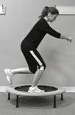
- Single leg squats on trampoline: Standing on one leg, slowly squat bending your knee from 0° to a maximum of 90°, making sure your knee does not move beyond your toes. Start with one set of 10 reps, holding each squat for 5 secs and increase the number of reps as your strength increases, up to 20 reps x 15 sec holds for each leg.

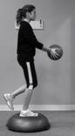
- Single leg stance with ball toss: Standing on one leg on a BOSU or other unstable surface (i.e. foam), toss and catch a light ball against a wall. Start with 2 sets of 10 tosses on each leg and increase as strength and balance improve.

Cardio: Maintain or improve aerobic fitness by doing 3 - 4, 30-minute workouts per week. Some ideas include walking, cycling (no mountain biking) and using an elliptical trainer.

** Perform all exercises once per day, 4-5 days per week to improve your strength and range of motion. You should perform all of the exercises on both legs**

ALSO CONSIDER:
- Hamstring curls in supine lying with a physio ball
- Wall squats (with/without ball squeeze)
- Double leg squats with ball squeeze
- Hip adduction: bridging with ball squeeze
- Stretching – stretch after exercising (quadriceps, hamstrings, calves, hip flexors and rotators)
- Pool ambulation: easy jogging in waist deep water or running in deep water with an aquabelt and swimming (no wip kick/egg beater) can be commenced around 12 weeks post-operative with approval from your surgeon
- If you have good balance and full ROM you can commence outdoor cycling on a smooth, flat surface at 12 weeks post-op with approval from your surgeon
- Cross-country skiing on even, flat surfaces can be commenced around 4-6 months post-operative with approval from your surgeon

REQUIREMENTS FOR PROGRESSION TO PHASE 4

Single leg squat with good motor control on an unstable surface to 70° flexion
  - Ability to demonstrate good core and posture in single leg stance activities
  - Evidence of improvement in strength (hamstrings, hip abductors, hip extensors, hip rotators)
  - Pain and swelling levels managed to enable exercise progression
  - Through-range hamstrings contraction against medium resistance

PHASE 4: Strength, Agility and Plyometrics
This phase begins as early as 6-months and may last up to 12-months post-operatively. This phase focuses on improving agility and power through plyometric exercises. Depending on pre-operative knee function this phase may not be completed by everyone following this protocol. Your goals and expectations for your knee should be discussed with your surgeon in consideration with what you can realistically attain.

GOALS

Increase agility using pivoting and jumping activities Commence jogging and running drills
Maximize quadriceps, hamstrings, hip and core strength with functional exercises

COLD THERAPY & ELEVATION
Manage your swelling by continuing to use cold therapy and elevation, especially after exercise or physiotherapy sessions.

EXERCISES

Strengthening: progressive strengthening program ensuring all muscle groups are included using functional exercises
- Quadriceps
- Hamstrings
- Hips
- Calves
- Core

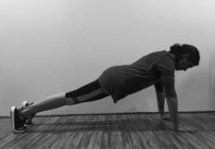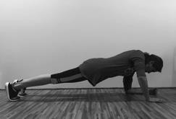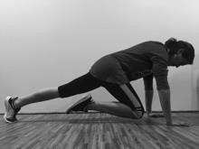Dynamic Core:
- Ups and downs: Assume a press up position so your hands are directly under your chest at shoulder width apart with straight arms. Your body should form a straight line from your shoulders to your ankles. Lift your left hand off the ground and then place your left forearm on the ground where your hand just was. Do the same with your right arm. Now pick your right forearm off the ground and put your palm back on the ground. Follow again with your left arm. This completes one repetition. Start with 1 set of 10. Increase the number of reps as your strength increases up to 3 sets of 10.
- Mountain climber: Assume a press up position so your hands are directly under your chest at shoulder width apart with straight arms. Your body should form a straight line from your shoulders to your ankles. Lift your right foot off the floor and slowly raise your knee as close to your chest as you can. Return to the starting position and repeat with your left leg. Start with 1 set of 10. Increase the number of reps as your strength increases up to 3 sets of 15.

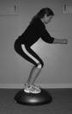
Proprioception:
- Squats on a BOSU: Slowly squat with equal weight on each leg. Bend your knees from 0° to a maximum of 90° of flexion, making sure your knees do not move beyond your toes. Start with one set of 10 reps, holding each squat for 5 secs and increase the number of reps as your strength increases, up to 20 reps x 15 sec holds on each leg. Progress to single-leg squats starting with 10 reps x 5 sec holds, increasing to 20 reps x 15 sec holds
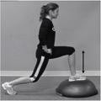
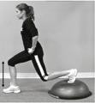
on each leg.
- Lunges on a BOSU: Step forward or back and lunge as shown. Control the descent ensuring your knee that is forward does not move beyond your toes. Start with 1 set of 10 reps, holding each lunge for 5 secs. Increase the number of reps as your strength increases up to 3 sets of 10 on each leg.
Plyometrics: You must be able to perform a very well controlled single leg squat before commencing plyometric exercises.
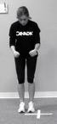
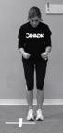
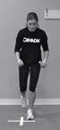
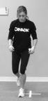
- Agility jumping: Start with straight-line jumping, backward/forward/side-to-side and progress to diagonals and combined patterns. Once speed and agility are good with jumping, progress through activities using single-leg hopping on each leg.
Agility jumping
Agility hopping

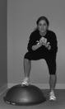
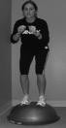
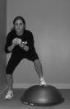
- Side to side steps on the BOSU: Perform quick steps in both directions over BOSU. Start with 1 set of 10 steps in both directions and progress to 3 sets of 15 steps in both directions as your strength increases.

- Straight line jumping activities (vertical jumps, shuttle jumps, standing long jumps)
- Straight line hopping activities (single leg hop for distance, timed single leg hop, single leg vertical hop, cross-over hopping)
- Straight line running activities (high knee lifts, glute kickers, shuttle sprints)
Jogging: recommended return to running progression
straight line activity ➔ indoor track ➔ treadmill (walk:run intervals) ➔ outdoor even ground

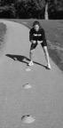
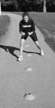
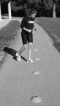
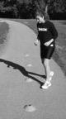
Running: shuttle runs, wide angle cutting, running and pivoting.

** Perform all exercises once per day, 4-5 days per week to improve your strength and range of motion. You should perform all of the exercises on both legs**

ALSO CONSIDER:
- Skipping rope – double and single leg
- Cariocas
- Box hop up/down (start at 6 inches)
- Tuck jumps
- Wobble-board balance activities
- Swimming
- Ice skating and cross-country skiing on even, flat surfaces may be commenced around 5-6 months post-operative with approval from your surgeon
- Mountain biking on easy trails may be commenced after your 6-month post-operative assessment with approval from your surgeon

REQUIREMENTS FOR PROGRESSION TO PHASE 5

Able to perform plyometric exercises with good motor and core control
  - Pain and swelling levels managed to enable exercise progression
  - Improved aerobic endurance and able to run on even surfaces
  - Good strength and endurance of bilateral lower extremities, greater than 80% of normal, on functional jump tests.

PHASE 5: Sport Readiness
This phase begins as early as 9 months and continues until 12+ months post-operatively. This phase involves return to functional activities including sports.

GOALS

Sport specific proprioception and agility Progressive plyometric exercises Return to sport specific training
COLD THERAPY & ELEVATION
Manage your swelling by continuing to use cold therapy and elevation, especially after exercise or physiotherapy sessions.

EXERCISES

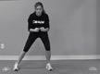
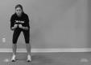
Agility:
- Running figure 8's around cones
- Agility ladder
- Grapevine / Cariocas
- Quick Lateral shuttles from cone to cone

Plyometrics:
- Box jumps
- Tuck jumps
- Hopping: 6m timed hop, triple hop for distance, crossover hop for distance

Running Drills:
- Shuttle sprints, stop and go drills
- Zig-zag running, sideways and backwards drills
- Sprinting with cutting and pivoting drills

Sport-specific Drills:
- Basketball: lay-up drills, lateral shuttle runs while throwing/catching ball off wall, run-pivot-vertical jump, dodging drills, defence drills (running/jumping backwards)
- Soccer: dribble around cones, shooting drills, defence drills, lateral shuttle runs while kicking ball off wall, tackling drills (not until 9-12 months post-op)
- Football/Rugby: dodging/deking drills, running and throwing drills (all directions), defence tackling drills (not until 9-12 months post-op)

- Hockey: skating figures, stick handling drills, shooting drills, deking drills, no contact drills until 9-12 months post-op

- Ski: free Ski/Carving drills, progression to gate

Used with permission from Banff Sport Medicine.
Please contact our office for more information:

Banff Sport Medicine
PO Box 1300 Banff, Alberta, Canada T1L 1B3 Phone: 403-760-2897 Ext 6
Fax: 403-760-8234
sarah@banffsportmed.ca www.banffsportmed.ca

