Dr. Akinbiyi
Dr. Wiens
Queen Elizabeth II Hospital
________________________________________________________________
Shoulder and Upper Extremity Research Group of Edmonton (SURGE) Rehabilitation Guidelines

Bankart and SLAP Repair

- Bankart Repair
- SLAP Repair
  - In addition, No Biceps strengthening x 8 weeks

Phase 1: Immobilization (0-4 weeks)
- Remain in shoulder immobilizer until 4 weeks or as dictated by surgeon
- You may come out of the sling 3-4 times a day for washing, physiotherapy exercises and simple ADL’s (brushing teeth, eating, writing) if pain-free.
- Placing a pillow behind your arm at night so it does not fall backwards or sleeping in a recliner may be more comfortable for the first few weeks.

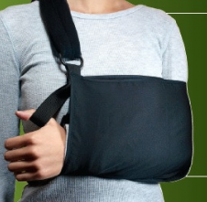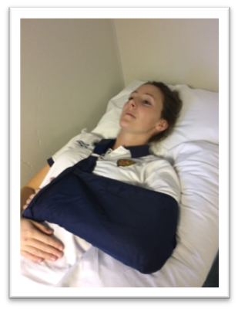

Precautions:
- For exercises, use your non operated arm or a cane (broom handle, hockey stick, putter etc.) to move the “operated” arm – this is called “active-assisted” range of motion (AAROM), as you always assist your arm to move.
- DO NOT move your operated arm forward more than 30 DEGREES (Flexion/Scaption)
- DO NOT rotate the operated arm outward (External Rotation) to more than NEUTRAL (when the forearm points straight forward in standing or straight up to the ceiling if lying on your back.
- No lifting, pushing, and/or pulling with the surgical arm.
Pain and Swelling Control:
- It is common to have quite a lot of pain for the first 2-6 weeks after surgery
- Discomfort is normal, especially with exercise
- Cold Therapy is very beneficial and may be used to help control pain and assist in healing. Cold Therapy can be used for 20 minutes, every 1-2 hours as needed. If using ice packs, place a dry towel over your incision to keep it from getting wet.

When exercising:
- Exercises start immediately (Day 1 after the operation)
- Do each exercise 2-3 times a day
- Do 2 sets of 10 repetitions (reps) for each exercise
- Move within pain-free limits (discomfort is okay)
- Always use your non-operated arm or a cane (broom handle, hockey stick, putter etc.) to move the operated arm – these exercises are called “active-assisted” range of motion (AAROM), as you always fully assist your arm to move.

Exercises after surgery (Weeks 0-4)

Hand/Wrist and Elbow Exercises
Complete these exercises with your arm in your sling or supported closely at your side resting on a pillow. Repeat these exercises 2-3 times/day, 10 repetitions each.

- Hand

Gently close your hand as far as you can, then open it fully. You may squeeze a soft sponge ball.
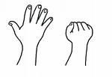
2. Wrist

Bend your wrist a) forwards and backwards, b) side to side and c) rotate palm up and palm down.

a) 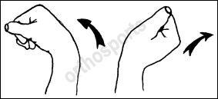 b) 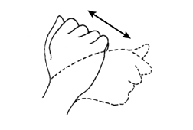 c)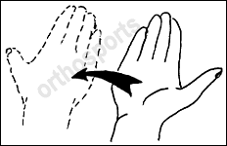

3. Elbow

*** For SLAP Repairs, use non-operated arm to assist bending the elbow

Remove your arm from your sling with help from the other arm. Straighten your elbow as much as you can, keeping your hand along your body. Now, bend your elbow again until your fingertips touch your shoulder. Repeat 2 sets of 10 repetitions or as pain allows.
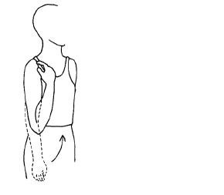

SHOULDER EXERCISES

Repeat these exercises 2-3 times/day, 2 sets of 10 repetitions each or as pain allows.

4. Shoulder Retraction and Retraction/Depression:

- Sit in a chair with your arm in your sling or resting on a pillow, keeping your neck and shoulder muscles relaxed
- Gently move your shoulder blades (a) back and in towards your spine and hold for 10 seconds. (b)Then move your shoulder blades back, in and downward. May progress to sitting on a physio ball or stand.

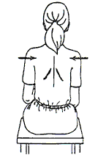

5. Standing Pendular Exercise

- Stand beside a table or counter supported by your good arm, with feet in a step stance position
- Bend forwards at the waist allowing your operated arm to hang in front of you
- Gently use the momentum of your body or your ‘good’ arm to move your operated arm in a circle to dinner plate circumference only
- *DO NOT use the muscles in the operated arm to move the arm.
- If your PT instructs you to, place your shoulder blade in a forward position or back position (scapular retraction/protraction) and repeat the pendular exercise in the new positions
- Repeat 2 sets of 10 in each direction (clockwise & counterclockwise).
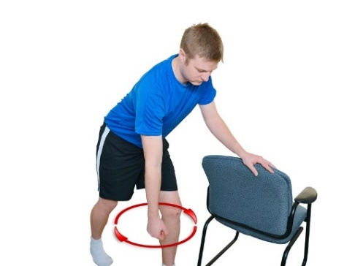

CIRCLES TO SIZE OF DINNER PLATE ONLY!

6. Shoulder Flexion and Scaption:

- In standing or lying on your back, holding onto a cane or a golf club.
- Use your non operated arm to move the cane and lift your operated arm straight forward (flexion) to 30 DEGREES ONLY.
- Now lift your arm slightly away from the body and forward (Scaption) to elevate your arm in the plane of the scapula to 30 DEGREES ONLY.
- Repeat each direction, 2 sets of 10 repetitions as pain allows.

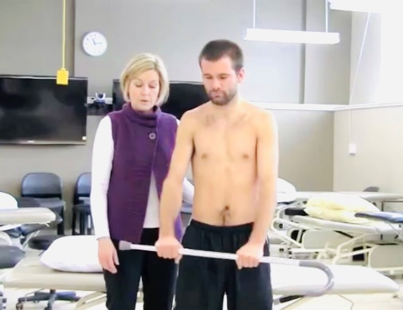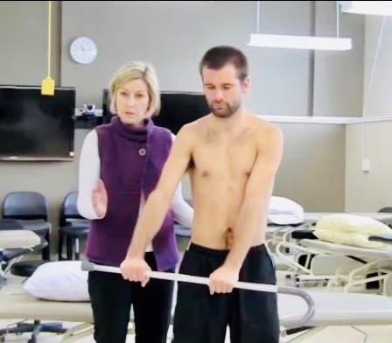
Flexion Scaption
(Flexion in the Scapular Plane -
Arm slightly away from body,
approximately 30 degrees)

7. Shoulder External Rotation:

- In standing or lying on your back, holding onto a cane or a golf putter, keep your elbow tucked in closely by your side.
- Use your good arm to slowly rotate your operated forearm outwards from your chest to NEUTRAL ONLY

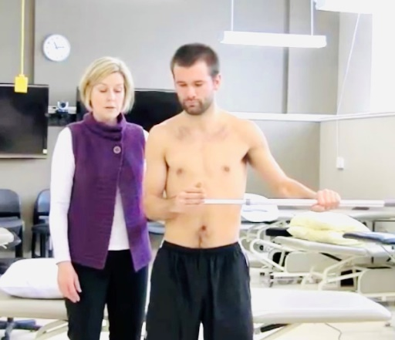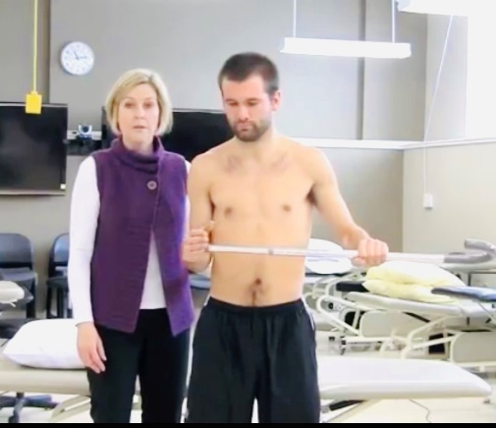

8) Shoulder Isometric Exercises:

- Do these exercises either with your operated arm in the sling or well supported on a pillow; place a towel between your chest wall and your elbow (see picture on next page).
- Wrap the hand of your non operated arm around the outside of the upper arm (near your elbow) of your operated shoulder for stabilization. Very gently and as pain allows, press your operated arm into your non operated hand and hold for 5 count in the following directions:
  - Press Forward
  - Press Backward

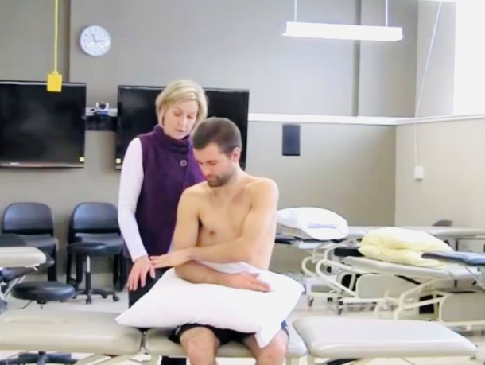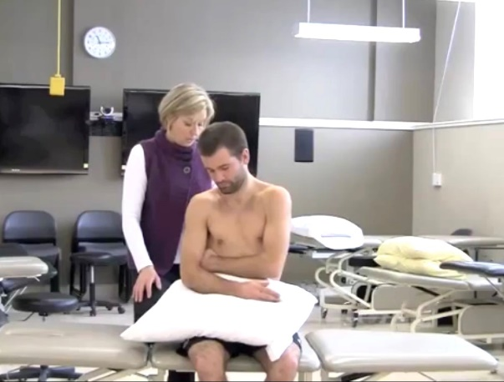
Forward Backward

- Now move your non operated hand down to your wrist. Very gently and as pain allows, press your operated arm into your non operated hand and hold for 5 counts in the following directions:
  - Press Outwards
  - Press Inwards

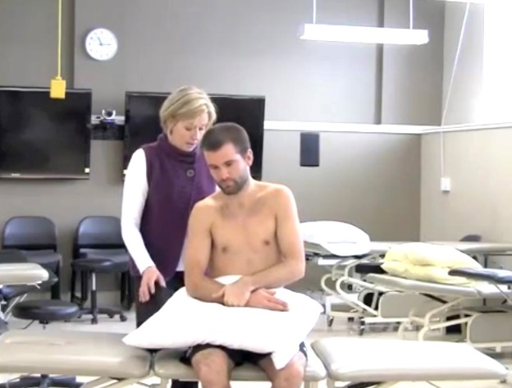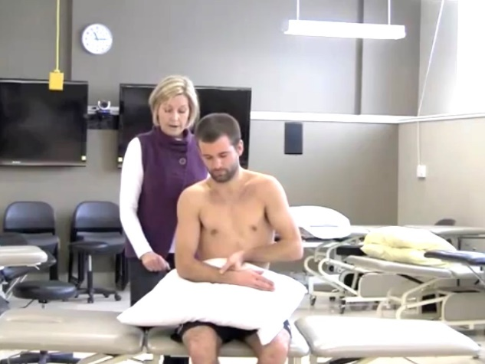
Outwards Inwards

* At 4 weeks, your Physiotherapist or Surgeon will progress you to the Phase II Exercises

Additional information:

Videos the shoulder exercises can be viewed at:

https://youtu.be/KgV9vlmaVNs or

http://rehabilitation.ualberta.ca/research/research-groups/shoulder-and-elbow-research-group-of-edmonton/shoulder-rehabilitation-guidelines (Videos: Phase 1 Bankart Repair Guidelines)

